C H A P T E R 1 3

Visual Design
The visual design of Microsoft Windows provides a consistent environment that transfers visual information to make the interface easy to use across applications and user tasks. This chapter covers guidelines related to the design of the visual and graphic aspects of the user interface.

Visual Communication
What we see influences how we feel and what we understand. Visual information communicates nonverbally, but very powerfully. We organize what we read and how we think about information by grouping it spatially. We read text by scanning the shapes of groups of letters. In addition, visuals include emotional cues that motivate, direct, or distract. We tend to describe graphic information with adjectives like “slick,” “boring,” “cool,” “conservative,” or “wild.”

Composition and Organization
Effective visual design serves a greater purpose than decoration; it is an important tool for communication. How you organize information on the screen can make the difference between a design that communicates a message and one that leaves users puzzled or overwhelmed.

We read a screen in the same way we read other forms of information. In western countries, this means left to right, top to bottom. The eye is always attracted to the colored elements before black and white, to isolated elements before elements in a group, and to graphics before text.

All visual elements influence one another. Effective design depends completely on context. In a graphical user interface, a graphic element and its function are completely interrelated. A graphical interface needs to function intuitively: it needs to look the way it works and work the way it looks.

Using Color
Color is a very important aesthetic property in the visual interface. Because color has attractive qualities, use it to identify things in the interface to which you want to draw a user’s attention; for example, the current selection. Color has an associative aspect as well: we often assume there is a relationship between items of the same color. Color also carries with it emotional or psychological qualities. For example, colors are often categorized as being cool or warm.

When used indiscriminately, color can have a very negative or distracting effect. It can affect not only a user’s reaction to your software but productivity as well, by making it difficult to focus on a task.

In addition, there are a few more things to remember about color.

• While you can use color to show relatedness or grouping, associating a color with a particular meaning is not always obvious or easily learned.
• Color is a very subjective property. Everyone has different tastes in color. What is pleasing to you may be distasteful to someone else.
• Some percentage of your users may be operating on equipment that only supports monochrome presentation.
• Interpretation of color can vary by culture. Even within a single culture people’s associations for color can differ.
• Some percentage of the population may have color-identification problems. For example, about 10 percent of the adult male population have some form of color confusion.

The following guidelines can be summarized for using color.

Use Color as a Secondary Form of Information
Color should be used as an additive, redundant, or enhanced form of information. Avoid relying on color as the only means of expressing a particular value or function. Shape, patterns, location, and text labels are other ways to distinguish information. It is also a good practice to design visuals in black and white or monochrome first, then add color.

Use a Limited Set of Colors
While the human eye can distinguish millions of different colors, using too many usually results in visual clutter and can make it difficult for the user to discern the purpose of the color information. The colors you use should fit their purpose. Muted, subtle, complementary colors are usually better than bright, highly saturated ones, unless you are really looking for the circus look and feel.

Color also affects color. Adjacent or background colors affect the perceived brightness or shade of a particular color. A neutral color (for example, light gray) is often the best background color. Opposite colors, such as red and green, can make it difficult for the eye to focus. Dark colors tend to recede in the visual space, while light colors come forward.

Allow Users to Change Colors
Because color is a subjective, personal preference, allow the user to change colors where possible. For interface elements, Windows provides standard system interfaces and color schemes. If you base your software on these system properties, you can avoid including additional controls, plus your visual elements are more likely to coordinate effectively when the user changes system colors. This is particularly important if you are designing your own controls or screen elements to match the style reflected in the system.

When providing your own interface for changing colors, consider the complexity of the task and skill of the user. The user finds it helpful if you provide palettes, or sets of colors, that work well together rather than providing the entire spectrum. You can supplement the palette with an interface that allows the user to add or change a color in the palette.

Using Dimensionality
Many elements in the Windows interface use highlighting and shading to provide a three-dimensional appearance. This emphasizes function and gives real-world feedback to the user’s actions. For example, command buttons look like real buttons. This allows the eye to discern natural visual cues and to discriminate between different types of information.

Windows uses three-dimensional effects based on a common light source, the conceptual direction that light would be coming from to produce the lighting and shadow effects used in the interface. The light source in Windows comes from the upper left.

In general, three-dimensional objects should look like their real-world counterparts. Introduce enough detail to communicate the real-world association and no more. In addition, avoid using three-dimensional effects for an element that is not interactive.

Basic Border Styles
Windows provides a unified visual design for building all visual components based on a three-dimensional design shown in Figure 13.1.

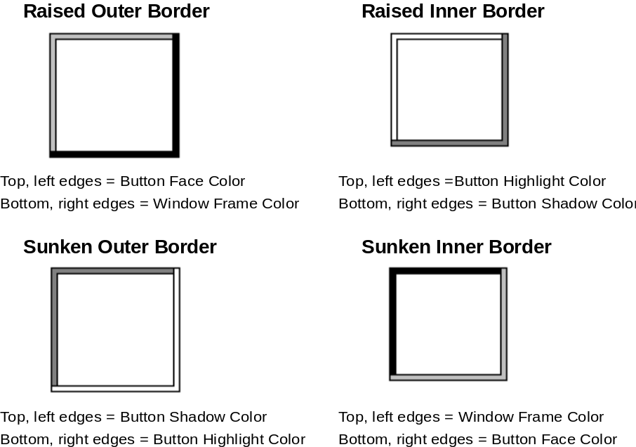

Figure 13.1 Basic Border Styles.
n Raised outer border — single-pixel width line on top and left edges in the color of the button face. The bottom and right edges use the color of the window frame.
n Raised inner border — uses the color of the button highlight for its top and left edges, and the color of the button shadow for its bottom and right edges.
n Sunken outer border — uses the color of the button shadow for its top and left border, and the color of the button highlight for its bottom and right edges.
n Sunken inner border — uses the color of the window frame for its top and left edges, and the color of the button face for its bottom and right edges.

If you use standard Windows controls and windows, these border styles are automatically supplied for your application. If you create your own controls, your application should map the colors of those controls to the same system colors so that the controls fit in the overall design of the interface when the user changes the basic system colors.

Window Border Style
The borders of primary and secondary windows should use the window border style, except for pop-up windows. You can also use it for menus and scroll arrow buttons and in situations where the background color varies. The border style is composed of the raised outer and raised inner basic border styles.

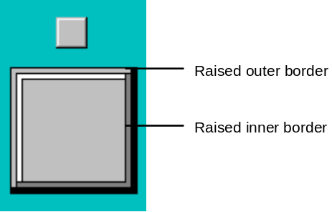
Figure 13.2 Window Border Style.

Button Border Styles
Command buttons should use the button border style. The button border style uses a variation of the basic border styles where the colors of the top and left outer and inner borders are swapped when combining the borders.

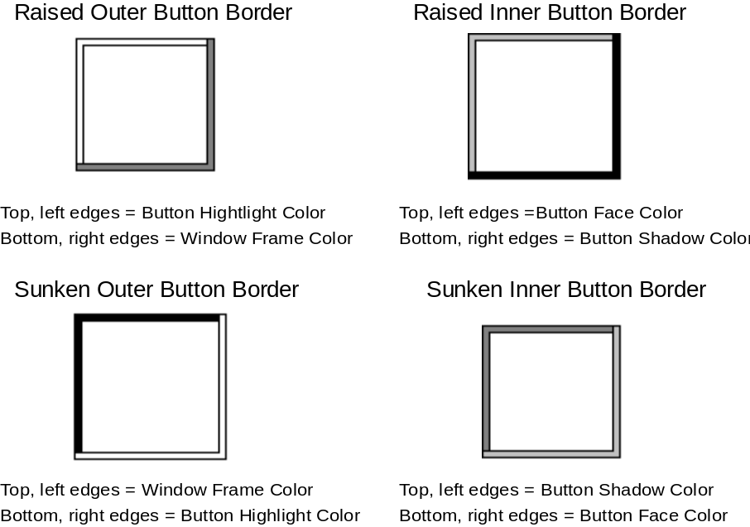

Figure 13.3 Button Border Styles.
The normal button appearance combines the raised outer and raised inner button borders. When the user presses the button, the sunken outer and sunken inner button border styles are used. The button down border style is also used for read-only fields (for example, read-only text boxes).

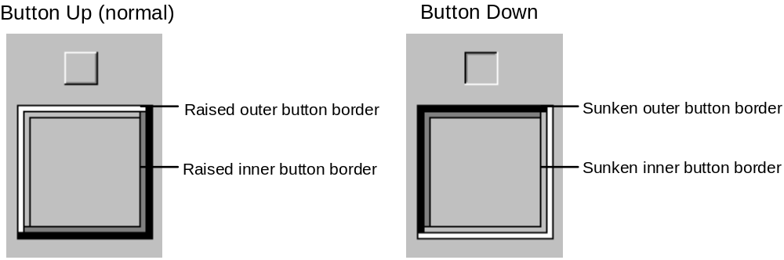
Figure 13.4 Button Up and Button Down Border Styles.

Field Border Style
You can use the field border style for text boxes (editable), check boxes, drop-down combo boxes, spin boxes, list boxes, and wells. Use the style to define the work area within a window as well. It uses the sunken outer and sunken inner basic border styles.

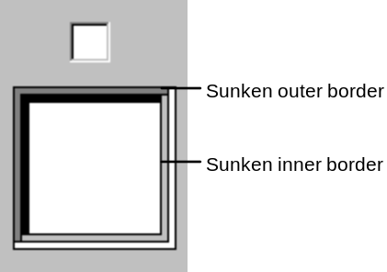

Figure 13.5 The Field Border Style.
For most controls, the interior of the field uses the color of the button highlight. However in drop-down lists, use the color of the button face; in wells, the color may vary based on what is placed in the field, such as a pattern or color swatch.

Status Field Border Style
You can use the status field border style for status fields. It uses only the sunken outer basic border style.

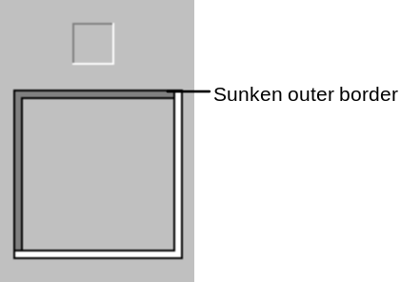

Figure 13.6 Status Field Border.

Grouping Border Style
You can use the grouping border style for group boxes and menu separators. The style uses the sunken outer and raised inner basic border styles.

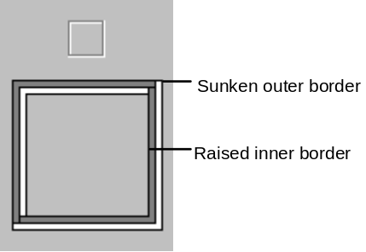

Figure 13.7 Group Border Style.

Using Fonts
Fonts have many functions in addition to providing letterforms for reading. Like other visual elements, fonts organize information or create a particular mood. By varying the size and weight of a font, we see text as more or less important and perceive the order in which it should be read.

By the very nature of the computer screen, fonts are generally less legible on-line than on a printed page. Avoid italic and serif fonts; these are often hard to read, especially at low resolutions.

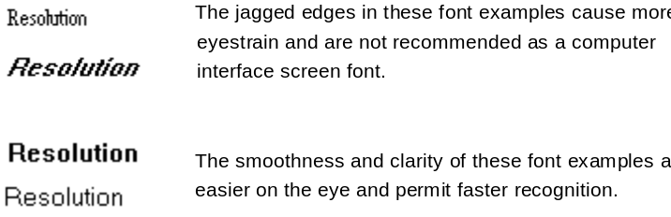
Figure 13.8
Limit the number of fonts and styles you use in your software’s interface. Using too many fonts usually results in visual clutter.

The standard fonts used in Windows (U.S. release) is MS Sans Serif for 8-point and 10-point sizes. Menu bar titles, menu items, control labels, and other interface text use 8-point MS Sans Serif. If a menu or control represents a default command, the text is bold. Title bar text also uses the 8-point MS Sans Serif bold font.

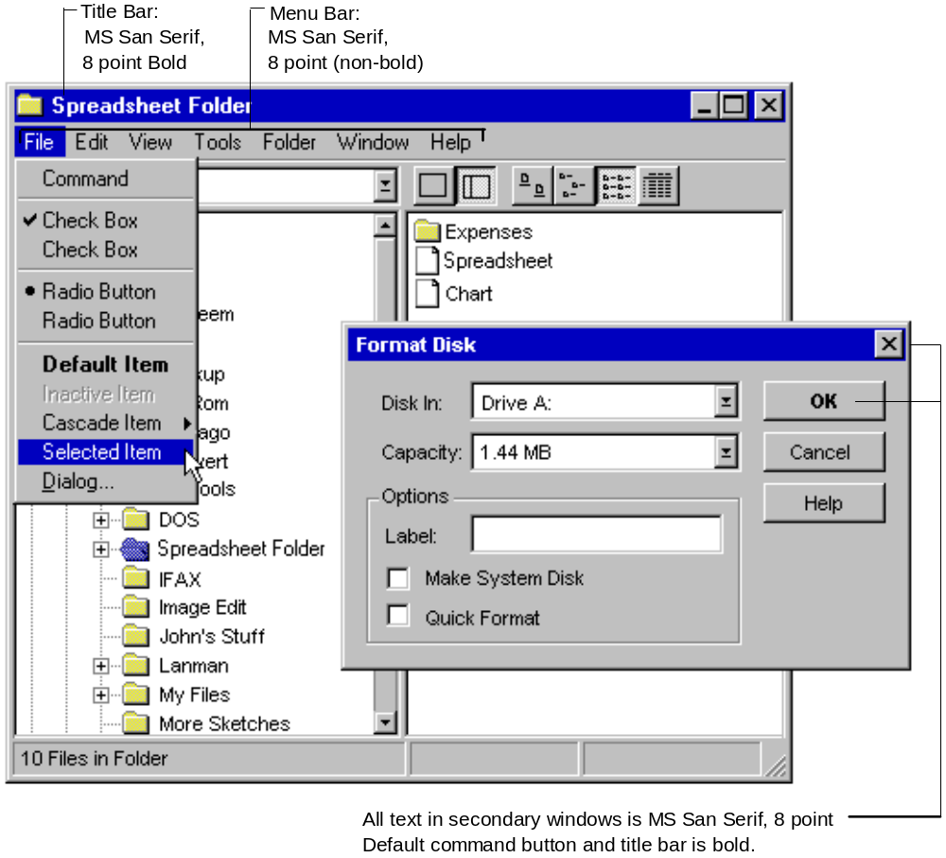
Figure 13.9 Font Usage in Windows.
When large point sizes are needed, use Arial instead. Wherever possible, use the standard system font, especially for common interface elements. This provides greater visual consistency between your software and the interface and also makes your interface scale more easily.

Visual Design of Controls
In addition to three-dimensional appearance and font usage, there are some other visual design details for controls. Specifically, these details address how to reflect different states of command buttons; however, these conventions may also be generalized for other types of custom controls. If you use standard Windows controls, Windows automatically provides these states. If you design your own controls, use the information in the following sections to make your controls consistent with the standard Windows controls.

Normal Appearance
Command buttons used as toolbar buttons should be 24 pixels wide by 22 pixels high on VGA resolution. This includes the border. For greater resolutions, proportionally size the button to be same height as a text box control. This allows the button to maintain its proportion with respect to other controls. The glyph used on the button should be 16 pixels wide by 16 pixels high for VGA resolution. For greater resolutions, stretch the glyph when the button is an even multiple of the VGA resolution; that is, if the button is twice as big, then double the glyph. Your application can also supply alternative images for higher resolutions. This may be preferable, because it provides better visual results. Center the button’s label on the button’s face.

Toolbar buttons generally only have graphical labels and no accompanying textual label. You can use tooltips to provide the name of the button.

Pressed Appearance
When pressing a control, the control’s appearance provides feedback about the down transition of the mouse button (for the pen, when the pen touches the screen and for the keyboard, upon the down transition of the keypress).

Standard Windows button controls, such as command buttons, check boxes, and option buttons, automatically provide this visual feedback.

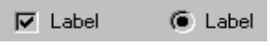

Figure 13.10 Pressed Appearance for Check Boxes and Option Buttons.
When pressing command buttons, the button down border style is used and the button label moves down and to the right (1 pixel).

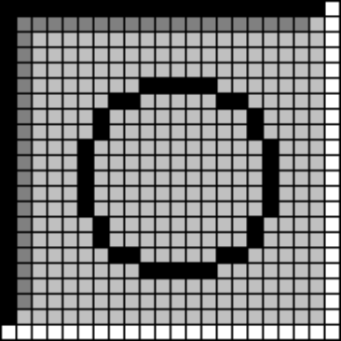

Figure 13.11 Magnified View of a Pressed Button.

Unavailable Appearance
When a control is unavailable (also referred to as disabled), its normal functionality is no longer available to the user (though it may still support access to Help information). Usually this is because the functionality represented does not apply or is inappropriate under the current situation or circumstances. To reflect this state, the label of the control is rendered with a special engraved appearance.



Figure 13.12 Unavailable Appearance for Check Boxes and Options Buttons.

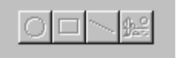

Figure 13.13 Buttons with Unavailable Appearance.
For graphical or textual buttons, create the engraved effect by drawing the label in the color of the button highlight and then overlaying it, at a small offset, with the image drawn in the color of the button shadow.

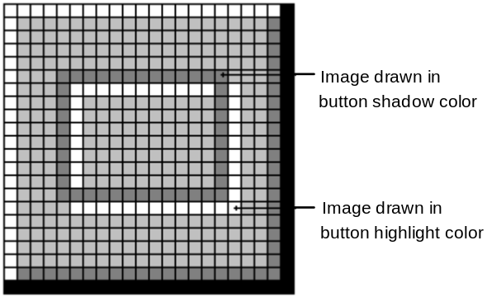

Figure 13.14 Magnified View of a Button with Unavailable Appearance.

Option-Set Appearance
When using button controls to indicate a set option or applicable state, the controls provide a visual indication, preferably one that is different than the pressed appearance. Use the option-set appearance upon the up transition of the mouse button, keypress, or pen tip.

Check box and option buttons automatically provide visual feedback when the option corresponding to that control is set. A check box uses a check mark, and an option button uses a large dot that appears inside the button.

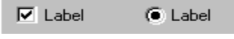

Figure 13.15 Option-Set Appearance for Check Boxes and Option Buttons.
When using command buttons to represent properties or other state information, the button face reflects when the option is set. The button continues to use the button down border style, but a hatched pattern the color of the button face and button highlight is displayed on the background of the button. The glyph on the button does not otherwise change from the pressed appearance.

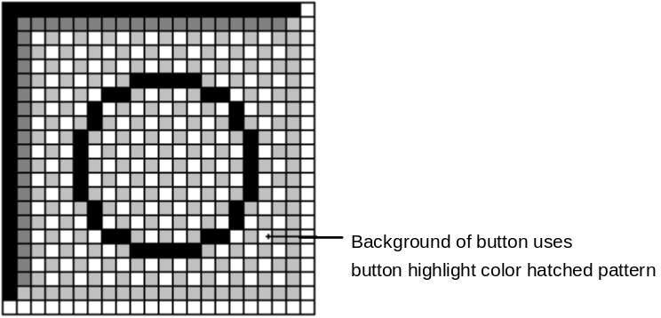
Figure 13.16 Magnified View of a Button with Option-Set State.
For well controls, when a particular choice is set it is indicated by a border around the control, using the text color and the color of the button highlight.

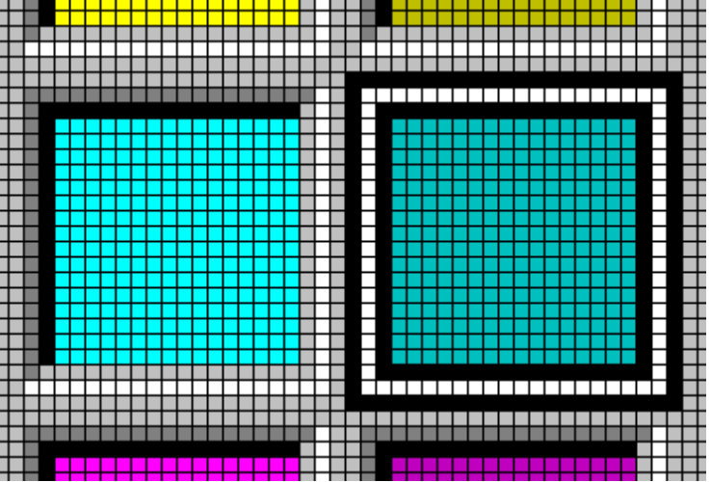

Figure 13.17 A Well with the Option-Set Appearance (Magnified).
If a button needs to reflect both the appearance of being set as well as unavailable, omit the background hatched pattern and use the unavailable appearance for the button’s label.

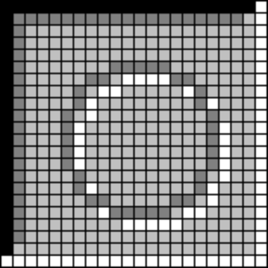

Figure 13.18 Magnified View of an Unavailable Option-Set Button.
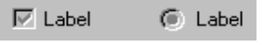

Figure 13.19 Unavailable Check Boxes and Option Buttons When the Option Is Set.

Mixed-Value Appearance
When controls represent properties and must reflect a set of objects where the values are different, render the control surface with mixed-value appearance (also known as indeterminate appearance).

Create the mixed-value appearance using a hatched or checkerboard pattern of the color of the button highlight.



Figure 13.20 Mixed-Value State for Check Boxes and Option Buttons.
For toolbar buttons, draw the pattern on the background of the button face.

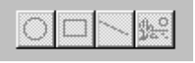

Figure 13.21 Buttons with Mixed-Value Appearance.

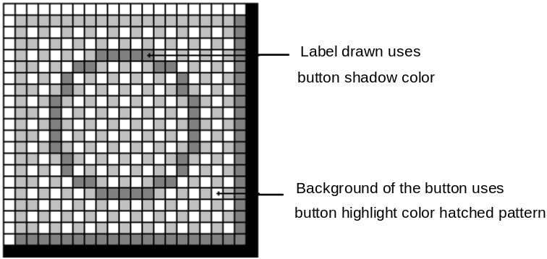

Figure 13.22 Magnified View of a Button with Mixed-Value Appearance.
If the control is a button, the typical behavior is to set the property value or state when the user clicks the button. Clicking a second time clears the value. Optionally, your software can support a third click to return the button to the mixed-value state.

Keyboard Focus Appearance
When using the keyboard for navigating to controls, provide a visual indication so the user knows where the input focus is. For text boxes, a blinking cursor or insertion point is usually best, for other controls, typically a dotted outline drawn in the window text color (COLOR_WINDOWTEXT) around the control or the control’s label.

illustration of dotted box
keyboard focus

Figure 13.23 Example of Keyboard Focus.

Flat Appearance
When you nest controls inside of a scrollable region or control, the controls should use the appearance shown in Figure 13.24.

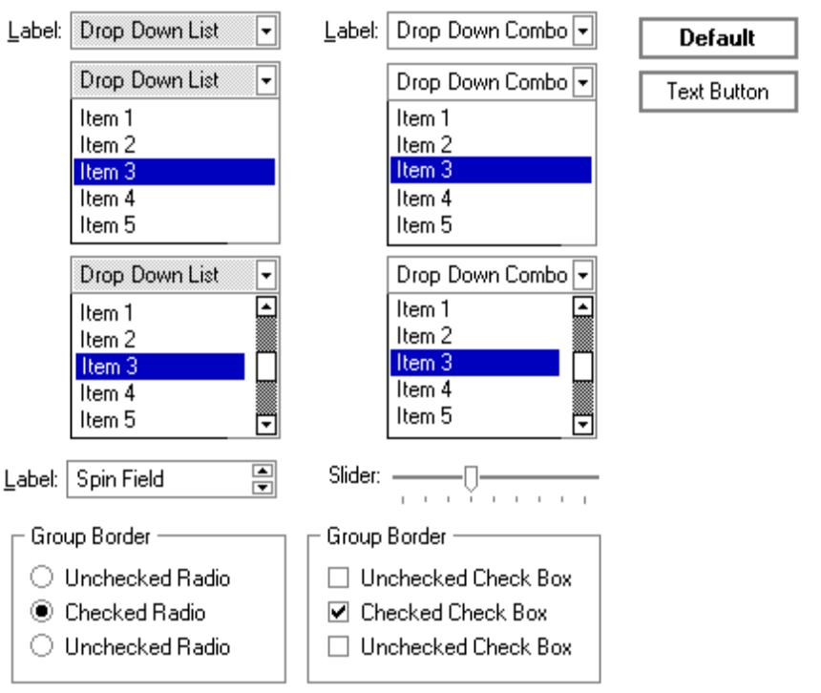
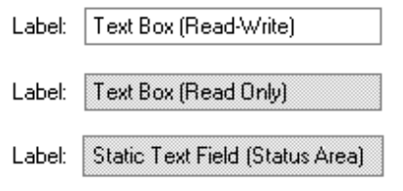

Figure 13.24 Flat Appearance for Standard Controls.
To display controls as unavailable, use the appearance shown in Figure 13.25.

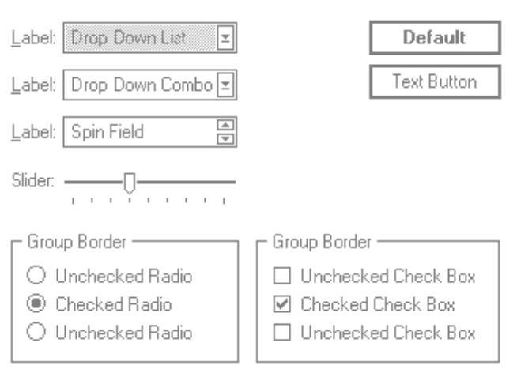


Figure 13.25 Unavailable Appearance for Nested Controls.

Selection Appearance
When the user selects an item, provide visual feedback to enable the user distinguish it from items that are not selected. Selection appearance generally depends on the object and the context in which the selection appears. For many items, the background or some distinguishing part of the object (for example, a resizing handle) is drawn using the highlight color (COLOR_HIGHLIGHT).

illustration
of a selection
of text
and a selection of graphics

Figure 13.26 Example of Selection Appearances.

Display an object with selection appearance when the user performs a selection action. For example, with the mouse, display selection appearance upon the press (button down transition) of the mouse button. For more information about selection techniques, see Chapter 4, “Input Basics.”

It is best to display the selection appearance only for the scope or area (window, pane, or control) that is active or currently receiving input from the user. This helps the user determine which selection currently applies as well as the extent of the scope of that selection. However, in some situations it may be important to simultaneously display selection appearances that affect another selected object (for example when simultaneous selection, such as a secondary window or menu, is used in an interface). If it is clear where the user is directing input, selection appearance can be shown simultaneously in both areas. Where your software needs to provide selection appearance, but as distinguished from the active selection, consider using a secondary selection technique, such as outlining the selection or using another color or a pattern.

Using Handles as Selection Appearance
As described in Chapter 5, “General Interaction Techniques,” use handles to provide access to an operation as well as indicate selection for some kinds of objects. The typical handle is a square box that appears on the edge of the object. The handle is “hollow” when the handle indicates selection, but is not a control point by which the object may be manipulated.

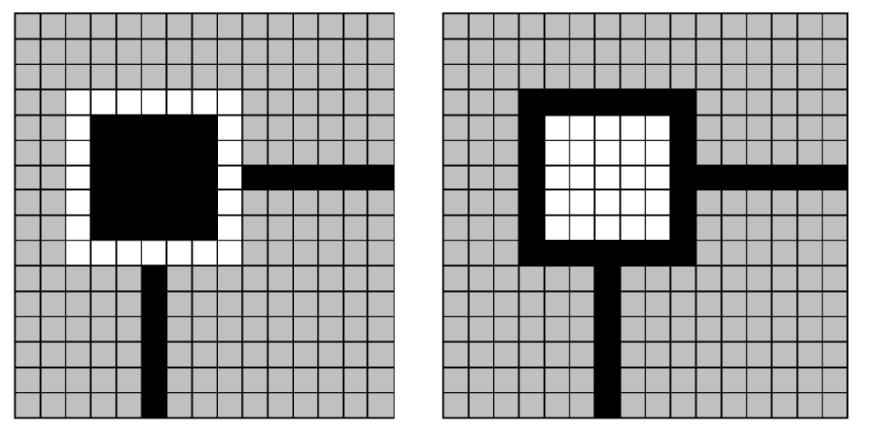
Figure 13.27 Magnified View of Normal (Left) and Hollow (Right) Handles.
Base the default size of a handle on the window border and edge metrics so that handle borders are appropriately sized when the user explicitly changes window border widths or for higher resolutions. This information is available using GETSYSTEMMETRICS (more specifically SM_CXEDGE, SM_CYEDGE, SM_CXBORDER, SM_CYBORDER).

Similarly, base the colors used to draw handles on system color metrics so that when the user changes the default system colors, handles appropriately change as well. The color of the border of normal handles should use the color of the highlighted text color (COLOR_HIGHLIGHTTEXT) for the border color and the color of the selection highlight (COLOR_HIGHLIGHT) for the fill color. Hollow handles use the opposite: selection highlight color for the border and highlighted text color for the fill color.

Transfer Appearance
When an object is dragged to perform an operation, for example, move, copy, print, and so on, a representation of that object moves with the pointer. In general, do not simply change the pointer to be the object, as this may obscure the insertion at some destinations. In addition, the pointer’s image is significant in communicating the way the transfer is interpreted by the destination. In this case, use a translucent or outline representation of the object that moves with the pointer.

illustration
of a translucent and outline
representation that moves with the
pointer

Figure 13.28 Translucent and Outline Representation During a Drag Transfer.
Create a translucent representation by using a checkerboard mask made up of 50 percent transparent pixels. When used together with the object’s normal appearance, this provides a representation that allows part of the destination to show through.

Icon Design
Use icons throughout the interface to represent objects. Because icons represent your software’s objects, it is important to not only supply effective icons, but to design them to effectively communicate their purpose.

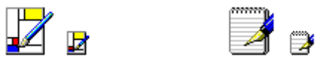

Figure 13.29 Example of Application Icons.
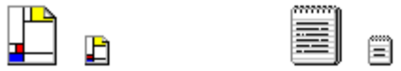

Figure 13.30 Examples of Document Icons.
If your software does not register any icons, the system automatically provides one; however, it is unlikely to be as detailed or distinctive as one you supply.

illustration
of
system generated icons

Figure 13.31 Example of System Generated Icons.

User Recognition and Recollection
User recognition and recollection are two important factors to consider in icon design. Recognition means that the icon is identifiable by users and easily associated with a particular object. Support user recognition by using effective metaphors. Use real-world objects to represent abstract ideas so that users can draw from previous learning and experiences. To facilitate recollection, design your icons to be simple and distinct.

Applying the icon consistently also helps build recollection; therefore design your small (16- by 16-pixel) icons to be as similar as possible to their larger (32- by 32-pixel) counterparts. It is generally best to try to preserve general shape and any distinctive detail.

Icons for documents (data files) should be distinct from the application’s icon. You may include some element of the application’s icon, but focus on making the document icon recognizable and representative of the file’s content.

Designing Graphics
When designing pictorial representation of objects, whether they are icons or graphical buttons, begin by defining the icon’s purpose as well as its use. You can then discuss other possible ideas, concentrating on real-world metaphors. It is often difficult to design icons that define operations or processes⎯activities that rely on verbs. Consider using nouns instead. For example, scissors can represent the idea of Cut.

Draw your ideas using an icon-editing utility or pixel (bitmapped) drawing package. Drawing them directly on the screen gives you immediate feedback about their appearance.

It is good idea to begin the design in black and white. Consider color as an enhancing property. Also, test your icons on different backgrounds. They may not always be seen on white or gray backgrounds.

Use an illustrative, rather than a symbolic style. Illustrative icons tend to communicate metaphorical concepts more effectively than abstract symbols. However, in designing an icon based on a real-world object, use only the appropriate amount of detail than is really necessary for user recognition and recall. Where possible and appropriate, use perspective and dimensionality (lighting and shadow) to better communicate the real-world representation.

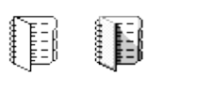

Figure 13.32 Use Perspective and Dimensionality in Your Icons.
Consistency is also important in icon design. As with other interface elements, design your icons assuming a light source from the upper left. In addition, make certain the scale (size) and orientation of your icons is consistent with the other objects to which it is related and fits well within the working environment.

The icon style recommendations have been slightly modified from those used in Windows version 3.1 to reflect the same light source as the system controls. Black outlines have also been eliminated to reduce visual clutter.

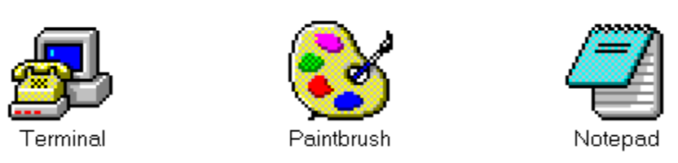

Figure 13.33 Windows Version 3.1 Icons.

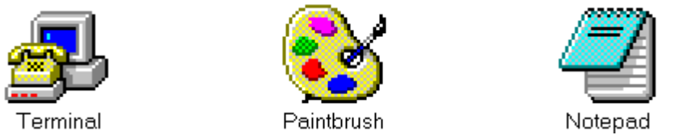

Figure 13.34 Revised Icons.
You may want to include a technique called anti-aliasing. Anti-aliasing involves adding colored pixels to smooth the jagged edges of a graphic. However, do not use anti-aliasing on the outside edge of an icon as the contrasting pixels will look jagged or fuzzy on varying backgrounds.

Finally, remember to consider the potential cultural impact of your icons. What may have meaning in one country or culture may not work in another. For more information about designing for international audiences, see Chapter 14, “Special Design Considerations.”

Layout
Size, spacing, and placement of information is critical in creating a visually consistent and predictable environment. While the information in this section is most applicable to controls in secondary windows, you can apply most of the guidelines in other areas of the interface.

Follow the layout convention for how information is read. In western countries, this means left-to-right, top-to-bottom with the most important information located in the upper-left corner.

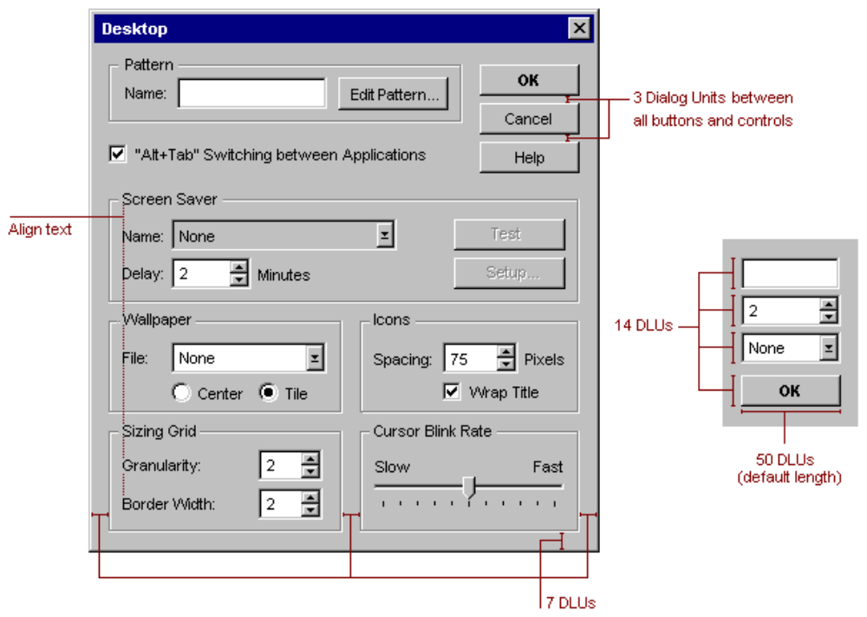
Figure 13.35 Suggested Spacing and Placement for Standard Controls and Text.

Size and Font
The default size for most single-line controls is 14 dialog units (DLUs). The default font size for text and labels is 8-point MS Sans Serif. Using the same size for fonts creates a visual grid that is easier to scan.

The recommended maximum size for secondary windows, such as dialog boxes and property sheets, is 234 DLUs wide by 263 DLUs high (415 pixels % 452 pixels). Maintaining this size keeps the window from becoming too large to display at some resolutions, as well as provide reasonable space to display supportive information, such as Help windows that may apply to the dialog box or property sheet.

Capitalization
When defining command names, use conventional title capitalization. Capitalize the first letter in each word unless it is an article or preposition not occurring at the beginning or end of the name, or unless the word’s conventional usage is not capitalized. For example:

Insert Object
Paste Link
Save As
Go To

Default names provided for title bar text or icon names also follow this convention. Of course, if a user supplies a name for an object, that name appears as the user specifies it, regardless of case.

Field labels, such as those used for option buttons, check boxes, text boxes, group boxes, and page tabs, should use sentence-style capitalization. Capitalize the first letter of the initial word and any words that are normally capitalized. For example:

Extended (XMS) memory
Working directory
Print to
Find whole words only

Grouping and Spacing
Group related components together. You can use group box controls or spacing. Leave at least 3 DLUs between controls. You can also use color to visually group objects, but this often involves design tradeoffs. Maintain consistent spacing (6 DLUs) from the edge of the window. Use spacing between groups within the window. For more information about the use of color, see the section “Color,” earlier in this chapter.

Space controls in a toolbar so that there is at least a window’s border width from the edges of the toolbar. You can apply the same measure for spacing between buttons, unless you want to align a set of related buttons adjacently. Use adjacent alignment for buttons that form an exclusive choice set. That is, when using buttons like a set of option buttons, align them without any spacing between them.

Alignment
When information is laid out vertically, align fields by their left edges (in western countries). This usually makes it easier for users to scan the information. Text labels are usually left aligned and placed above or to the left of the areas to which they apply.

Transaction Buttons
Stack the main command buttons in a secondary window in the upper-right corner or in a row along the bottom. If there is a default button, it is typically the first button in the set. Place OK and Cancel buttons next to each other. The last button is a Help button (if supported).

For easy readability, make buttons a consistent length. However, if maintaining this consistency greatly expands the space required by a set of buttons, it may be reasonable to have one button larger than the rest.

Placement of transaction buttons (or other controls) within a tabbed page implies the application of only the transactions on that page. Transaction buttons placed within the window, but not on the tabbed page, apply to all transactions in the entire window.

Using Animation
Animation can be an effective way to communicate information. For example, it can illustrate the operation of a particular tool or reflect a particular state. You can use animation effects for objects within a window as well as interface elements such as icons and pointers.

Effective animation involves many of the same design considerations as other graphics elements, particularly with respect to color and sound. For animation designed for fluid presentation, present images at 16 (or more) frames per second.

When you add animation to your software, ensure that it does not affect the interactivity of the interface. Do not force the user to remain in a modal state to allow the completion of the animation. Unless animation is part of a process, make it interruptible by the user or independent of the user’s primary interaction.

Avoid gratuitous use of animation. Animation that for decorative effect may distract or annoy the user. You may want to provide users with the option of turning off the animation.

Pointer Design
You can use the pointer design to help the user identify objects as well as provide feedback about certain conditions or states. However, use pointer changes conservatively so that the user is not distracted by excessive flashing of multiple pointer changes while traversing the screen. One way to handle this is to use a time-out before making noncritical pointer changes.

When you use a pointer to provide feedback, use it only over areas where that state applies. For example, when using the hourglass pointer to indicate that a window is temporarily noninteractive, if the pointer moves over a window that is interactive, it should be changed to its appropriate interactive image.

Pointer feedback may not always be sufficient. For example, for processes that last longer than a few seconds, it is better to use a progress indicator that indicates progressive status, elapsed time, estimated completion time, or some combination of these to provide more information about the state of the operation.

The location for the hot spot of a pointer is important for helping the user target an object. The pointer’s design should make the location of the hot spot intuitive. For example, for a cross-hair pointer, the implied hot spot is the intersection of the lines.

Example of a cross-hair pointer 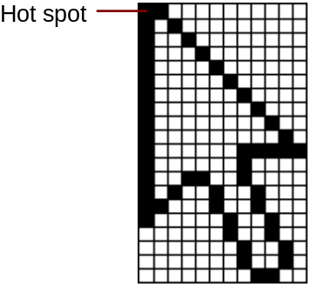

Figure 13.36 Examples of Pointer Designs and Hot Spots.
Animating a pointer can be a very effective way of communicating information. However, remember that the goal is to provide feedback, not to distract the user. In addition, pointer animation should not restrict the user’s ability to interact with the interface.

